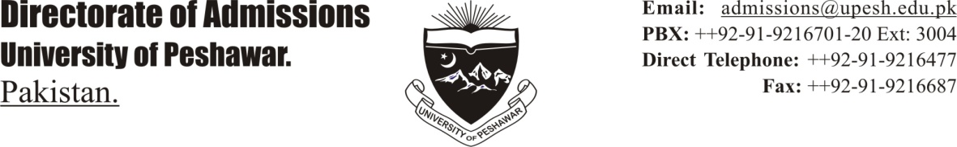DIRECTORATE OF ADMISSIONS

UNIVERSITY OF PESHAWAR

Admission Notice

*BS Home Economics (4 year Programme)*

*(Session 2012-13)*

Application forms for admission to BS Home Economics *(4 year Programme)* for the Session 2012-13 are invited on prescribed form obtainable from College of Home Economics on cash payment, so as to reach the College Office by 29.08.2012 positively.

ELIGIBILITY

1. F.Sc. (Pre-medial, Pre-Engineering, General Science at least 2nd Division)
2. F.A. (at least 2nd Division)

(c) F.Sc. (Home Economics, at least 2nd Division)

SCHEDULE

|  |  |  |  |
| --- | --- | --- | --- |
| S.No | Particulars | Date | Timings |
| 1 | Test for Hafiza Quran | 04.09.2012 | 10.00 a. m. |
| .2 | Display of Merit List | 10.09.2012 | 09:00 a.m. |
| 3 | Interviews from open merit list | 13.09.2012 | 09:00 a.m. – 01.00 p.m. |
| 4 | Interviews from waiting list | 17.09.2012 | 09:00 a.m. – 01.00 p.m. |

NOTE:

* Application forms sent by post or submitted after due date and those incomplete shall not be considered.

*(Prof. Dr. Hizbullah Khan)*

DIRECTOR ADMISSIONS

No. _446 - 460_ / Dir/Admissions/ B.Sc (H.Eco)/Adv-2012-13, dated 08.03.2012

Copy to:

1. *The Principal, College of Home Economics, University of Peshawar.*
2. *The Treasurer, University of Peshawar.*
3. *The Additional Treasurer, University of Peshawar.*
4. *The Dy. Registrar (Admissions) for information.*
5. *The PRO for publishing the advertisement in the Daily “Aaj & The News,” on 04.08.2012 positively.*
6. *P.S. to Vice-Chancellor, University of Peshawar.*
7. *P.S. to Registrar, University of Peshawar.*
8. *Incharge, University EIT Lab, University of Peshawar for information.*
9. *Supdt-II, Directorate of Admissions, University of Peshawar*
10. *Information Counter, University Administration Block, University of Peshawar*
11. *Supervisor, Telephone Exchange, University of Peshawar.*

DIRECTOR ADMISSIONS