**ISSB Mechanical Apptitude Test Sample 2013**

Top of Form

If the wheel rotates as shown, P will

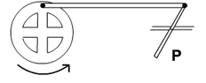

* move to the right and stop
* move to the left and stop
* move to and fro
* none of these

Which way does wheel X move?

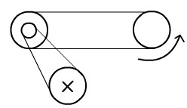

* either
* anti-clockwise
* clockwise
* stays still

Which nail is most likely to pull out of the wall?

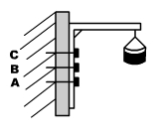

* A
* B
* C
* All equally likely

Which tank will cool water fastest?

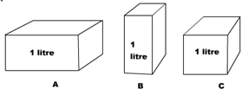

* A
* B
* C
* All equal

Which tent peg will give the best hold on soft ground?

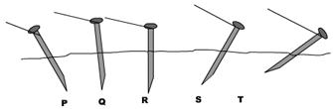

* P
* Q
* R
* S
* T

Which weight will be easiest to lift?

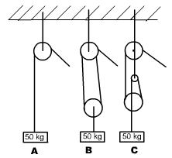

* A
* B
* C
* All equal

Which plank is most likely to break?

[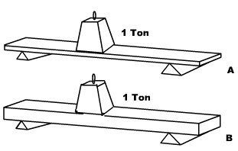](http://issbpreparation.com/wp-content/uploads/2011/11/mechanical_aptitude_question-8.gif)

* A
* B
* Either

If the handle is moved as shown, how will the hooks M & N move?

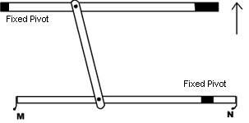

* M up, N down
* M down, N up
* M up, N up
* M down, N down
* M up, N still

The diameter of pulleys A and C is 10 cm and pulleys B and D is 5 cm. When pulley A makes a complete turn, pulley D will turn

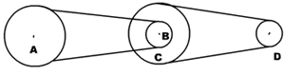

* Once
* Twice
* 4 Times
* 6 Times
* 8 Times

If the drawing is of water pipes, which will carry most water per metre length?

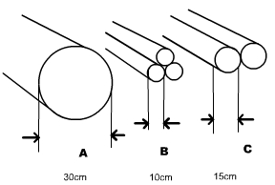

* A
* B
* C
* All

If the blocks are all of the same material, which is the heaviest?

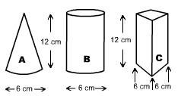

* A
* B
* C
* All equal

Which chain would support the weight by itself?

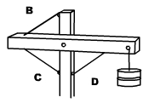

* B
* C
* D
* All equal

Bottom of Form