BAHAUDDIN ZAKARIYA UNIVERSITY, MULTAN
NOTIFICATION NO. 356 /C.B.
DATE SHEET FOR M.A./M.SC. PART-I (ANNUAL SYSTEM), 2nd ANNUAL EXAMIANTION 2015 & 1st ANNUAL EXAMINATION 2016 (OLD & NEW COURSE)
TO BE HELD IN OCTOBER - 2016. (WRITTEN EXAMINATION)
TIME: 09:00 A.M.
DATE& DAY | SUBJECT | Paper | T I T LE
20.10.2016  Thursday | Arabic | I | القواعد العربیۃ Arabic Grammar
20.10.2016  Thursday | Botany | I | Virology, Bacteriology ,Mycology & Plant Pathology
20.10.2016  Thursday | Economics | I | Micro Economics Theory
20.10.2016  Thursday | Education | I | Foundations of Education
20.10.2016  Thursday | Punjabi | I | Takhleeqi Nasar
20.10.2016  Thursday | Pakistan Studies | I | Geography of Pakistan
20.10.2016  Thursday | Philosophy | I | History of Greek Philosophy.
20.10.2016  Thursday | Statistics | I | Statistical Methods & Statistical Quality Control
21.10.2016  Friday | English Lit. | I | Poetry
21.10.2016  Friday | Mathematics | 301 | Real Analysis
21.10.2016  Friday | Persian | I | دستور زبان و ترجمہ
21.10.2016  Friday | Physics | I | Methods of Mathematical Physics.
21.10.2016  Friday | Psychology | I | Historical and Contemporary Psychology
21.10.2016  Friday | Political Science | I | Western Political Thought
21.10.2016  Friday | Saraiki | I | سرائیکی زبان تے ادب دی تاریخ
21.10.2016  Friday | Sociology | I | Principal of Sociology
22.10.2016  Saturday | Arabic | II | Al-lughat-Ul-wazeefa ( Functional Language)
22.10.2016  Saturday | Botany | II | Plant Morphology
22.10.2016  Saturday | Chemistry | V | Bio-Chemistry
22.10.2016  Saturday | Economics | II | Macro Economics Theory
22.10.2016  Saturday | Education | II | Educational Psychology
22.10.2016  Saturday | Pakistan Studies | II | Muslim Nationalism in South Asia (1858-1947)
22.10.2016  Saturday | Statistics | II | Probability and Probability Distribution
24.10.2016  Monday | English Lit. | II | Drama
24.10.2016  Monday | History | II | Muslim Struggle for Independence(1858-1947)
24.10.2016  Monday | Mathematics | 302 | Modern Algebra-I
24.10.2016  Monday | Persian | II | نثر کلاسک فارسی
24.10.2016  Monday | Physics | II | Classical Mechanics Thermodynamics & Statistical Physics
24.10.2016  Monday | Psychology | II | Learning ,Cognition and Motivation
24.10.2016  Monday | Political Science | II | Muslim Political Thought & Institutions
24.10.2016  Monday | Saraiki | II | کلاسیکی سرائیکی شاعریclassical Saraiki Shairee
24.10.2016  Monday | Sociology | II | Sociological Theory
25.10.2016  Tuesday | Arabic. | III | النثر القدیم و الحدیث
25.10.2016  Tuesday | Botany | III | Plants Systematic & Bio-Diversity
25.10.2016  Tuesday | Economics | III | Mathematical Economics
25.10.2016  Tuesday | Education | III | Methods of Educational Research
25.10.2016  Tuesday | Punjabi | III | کلاسیکی شاعری
25.10.2016  Tuesday | Pakistan Studies | III | Pakistan Society and Culture
25.10.2016  Tuesday | Philosophy | III | Moral Philosophy
25.10.2016  Tuesday | Statistics | III | Sampling Techniques.
25.10.2016  Tuesday | Urdu | III | و اسالیب نثر ارد
(PAGE 1/3)

DATE& DAY | SUBJECT | Paper | T I T LE
26.10.2016  Wednesday | History | III | Govt. & Politics in Pakistan (1947-1999)
26.10.2016  Wednesday | Mathematics | 303 | Differential Equations
26.10.2016  Wednesday | Physics | III | Quantum Mechanics.
26.10.2016  Wednesday | Psychology | III | Statistics
26.10.2016  Wednesday | Islamic Studies | II | Mutala Hadees
26.10.2016  Wednesday | Political Science | III | Comparative & Developmental Politics
26.10.2016  Wednesday | Saraiki | III | افسانوی ادب
26.10.2016  Wednesday | Sociology | III | Method of Social Research
27.10.2016  Thursday | Arabic | IV | الادب القصصی
27.10.2016  Thursday | Botany | IV | Plant Anatomy
27.10.2016  Thursday | Chemistry | IV | Analytical Chemistry
27.10.2016  Thursday | Economics | IV | Descriptive & Inferential Statistics
27.10.2016  Thursday | Education | IV | Curriculum Development (New Course)
27.10.2016  Thursday | Punjabi | IV | خصوصی مطالعہ وارث شاہ
27.10.2016  Thursday | Pakistan Studies | IV | Constitutional Development in Pakistan (1947-1999)
27.10.2016  Thursday | Philosophy | VI | Introduction to Psychology
27.10.2016  Thursday | Statistics | IV | Data Processing & Statistical Computing
27.10.2016  Thursday | Urdu | IV | تاریخ زبان و ادب اردو
28.10.2016  Friday | English Lit. | IV | Criticism
28.10.2016  Friday | Islamic Studies | V | تقابل ادیان
28.10.2016  Friday | History | IV | International Relations & Organization 1945-2000
28.10.2016  Friday | Mathematics | 304 | Complex Analysis & Different Geometry
28.10.2016  Friday | Persian | IV | ادبیات معاصر فارسی
28.10.2016  Friday | Physics | IV | Analog Electronics.
28.10.2016  Friday | Psychology | IV | Methods of Behavioral Research
28.10.2016  Friday | Political Science | IV | International Relations.
28.10.2016  Friday | Saraiki | IV | فریدیات
28.10.2016  Friday | Sociology | IV | Social Statistics and Applications of Computer in Sociology
29.10.2016  Saturday | Arabic | V | الادب الدینی Religious Literature
29.10.2016  Saturday | Botany | V | Cell & Molecular Biology & Bio-Statistics
29.10.2016  Saturday | Chemistry | II | Organic Chemistry
29.10.2016  Saturday | Economics | V | Monetary Eco. & Public Finance
29.10.2016  Saturday | Education | V | Educational Measurement & Evaluation
29.10.2016  Saturday | Punjabi | V | تاریخ پنجابی زبان و ادب
29.10.2016  Saturday | Pakistan Studies | V | Foreign Policy of Pakistan (1947-1999)
29.10.2016  Saturday | Philosophy | V | Logic
29.10.2016  Saturday | Urdu | V | تنقید
31.10.2016  Monday | English Lit. | V | History of English Literature
31.10.2016  Monday | Islamic Studies | IV | سیرۃ النبی
31.10.2016  Monday | History | V | Historiography
31.10.2016  Monday | Mathematics | 305 | Tensor Analysis & Mechanics
31.10.2016  Monday | Persian | V | تاریخ ادبیات فارسی برصغیر پاکستان و ہند
31.10.2016  Monday | Political Science. | V | Genesis of Pakistan.
31.10.2016  Monday | Siraiki | V | Saraiki waseb de tarkikh tay sakafat
31.10.2016  Monday | Sociology | V | Cultural Anthropology
01.11.2016  Tuesday | Arabic | VI | العربی الادب تاریخ
01.11.2016  Tuesday | Botany | VI | Plant Ecology.
01.11.2016  Tuesday | Chemistry | III | Physical Chemistry
01.11.2016  Tuesday | Economics | VI | Development Economics
01.11.2016  Tuesday | Punjabi | VI | Look Adab
01.11.2016  Tuesday | Education | VI | Methods and Techniques of Teaching
01.11.2016  Tuesday | Pakistan Studies | VI | Economic Development of Pakistan(1947-1999)
01.11.2016  Tuesday | Philosophy | IV | Problem of Philosophy
01.11.2016  Tuesday | Urdu | VI | ُ پا کستا ن زبانوں کا ادب
(PAGE 2/3)

DATE& DAY | SUBJECT | Paper | T I T LE
02.11.2016  Wednesday | English Lit. | VI | Linguistics
02.11.2016  Wednesday | History | VI | State & Society during Muslim Rule in India
02.11.2016  Wednesday | Islamic Studies | VI | Islam kay Moasharty ,Moashi Iktdar –Tasavarat
02.11.2016  Wednesday | Mathematics | 306 | Computer Applications & Programming for Math 1st
02.11.2016  Wednesday | Mathematics | 306 | Computer Applications, Mathematics & Fortan 90
02.11.2016  Wednesday | Persian | VI | Junobi Punjab main Farsee Shairee
02.11.2016  Wednesday | Psychology | VI | Psychopathology
02.11.2016  Wednesday | Political Science | VI | Research Methodology
02.11.2016  Wednesday | Saraiki | VI | 1.Ablaghee Maharatain  2. Saraiki Grammar Tay Composition
02.11.2016  Wednesday | Sociology | VI | Social Psychology
03.11.2016  Thursday | Economics | VII | Islamic Economics
03.11.2016  Thursday | Statistics | V | Design & Analysis of Experiments
03.11.2016  Thursday | Philosophy | II | Classical Muslim Philosophy
03.11.2016  Thursday | Punjabi` | II | جدید شاعری
03.11.2016  Thursday | Urdu | I | کلاسیکی شاعری
04.11.2016  Friday | Chemistry | I | Inorganic Chemistry
04.11.2016  Friday | English Lit. | III | Academic Discourse
04.11.2016  Friday | History | I | History of Islam Pre-Islam Arabia to 661-AD
04.11.2016  Friday | Islamic Studies | III | عربی زبان و ادب
04.11.2016  Friday | Psychology | V | Psychology of Human Relations
04.11.2016  Friday | Persian | III | Shair Classical Pharseee
05.11.2016  Saturday | Urdu | II | افسانوی ادب
07.11.2016  Monday | Islamic Studies | I | Mutala Tafseer Quran

Dated:- 11.10.2016

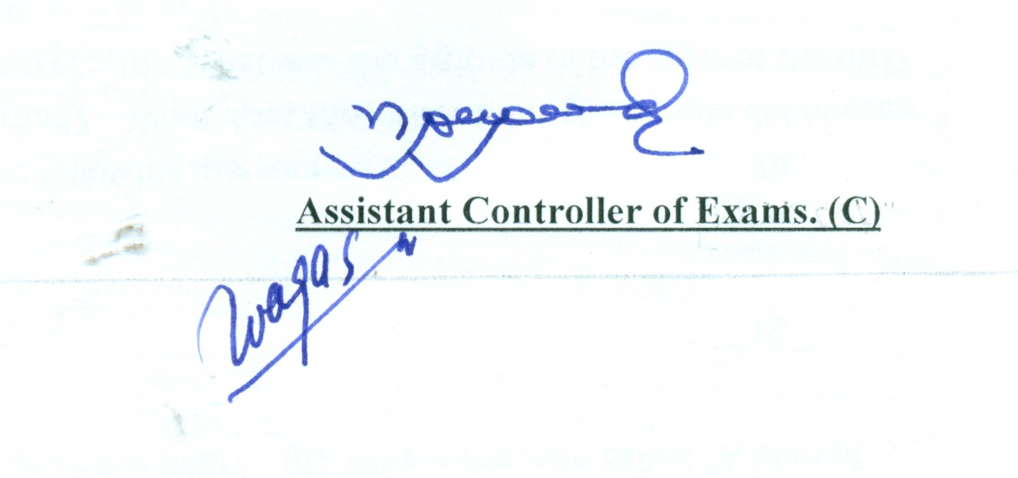

(PAGE 3/3)

