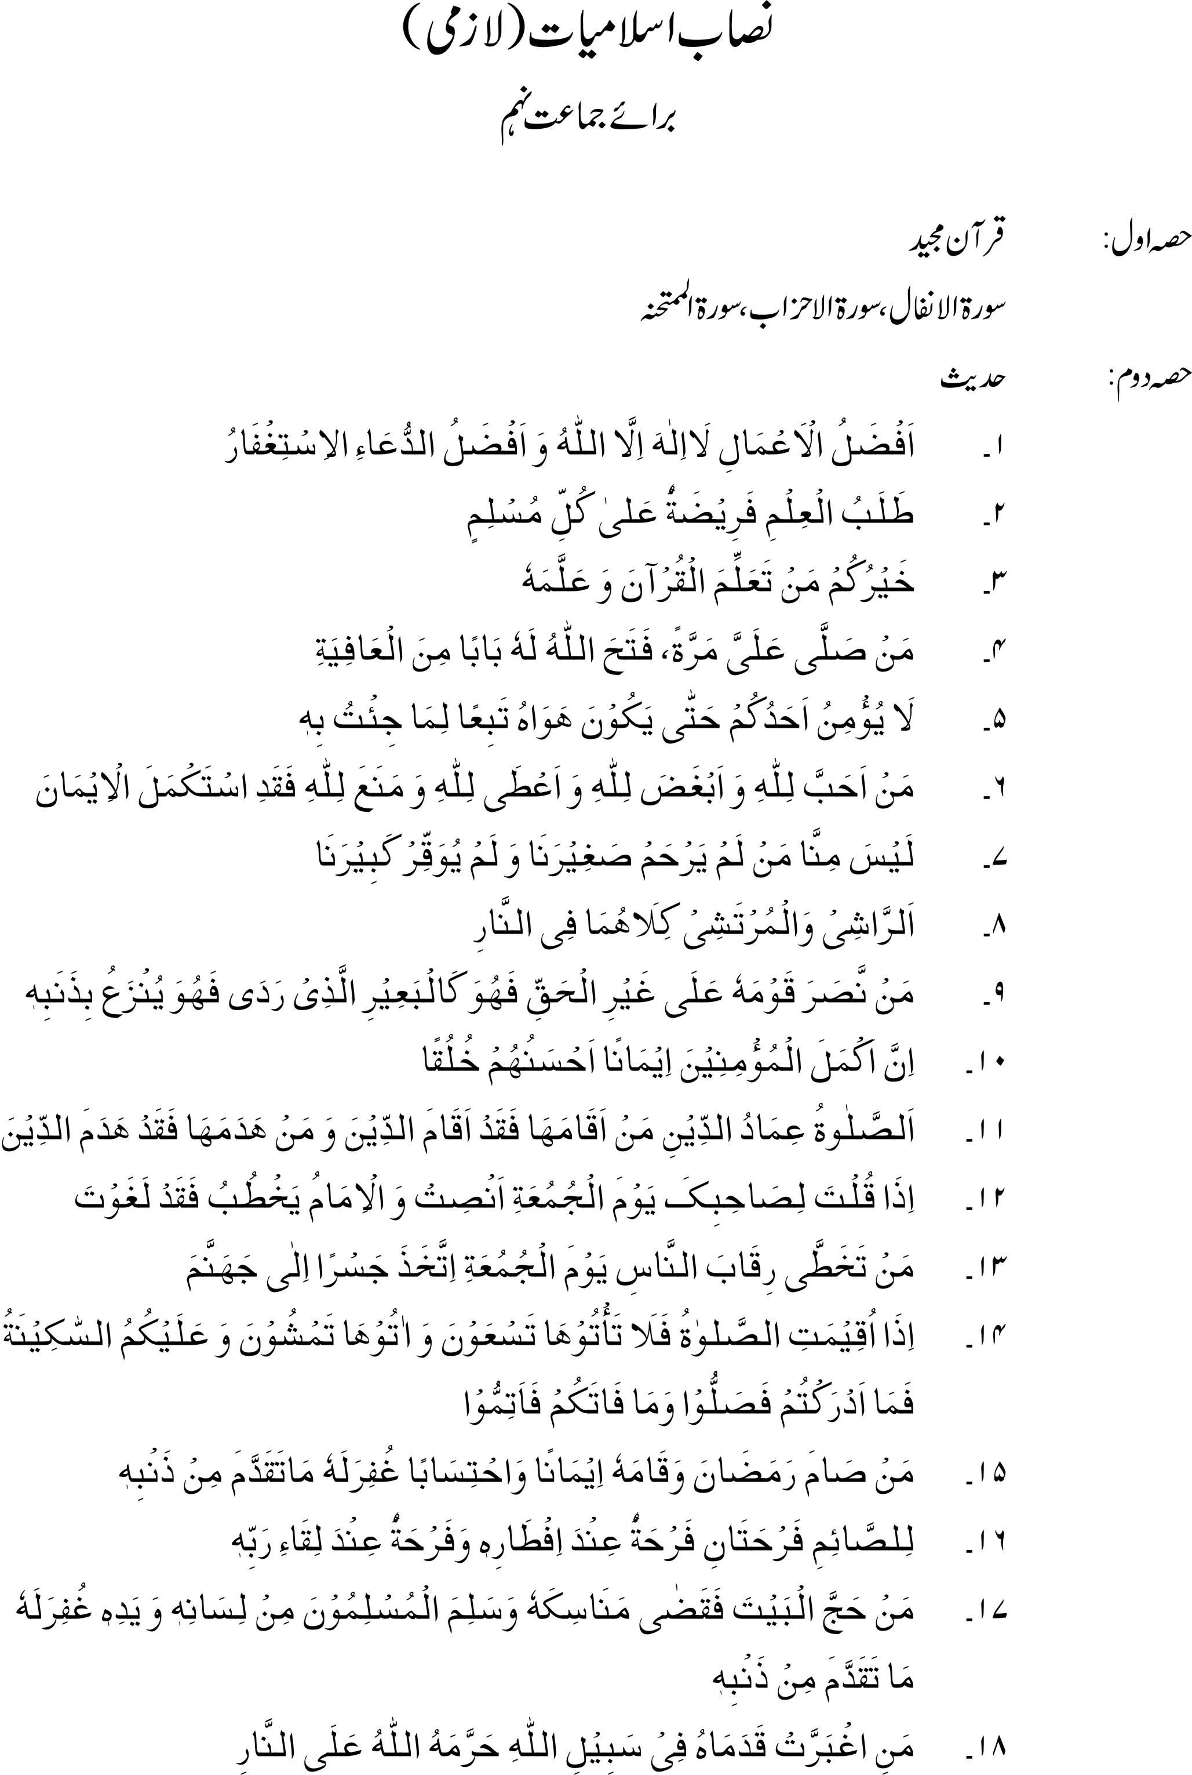

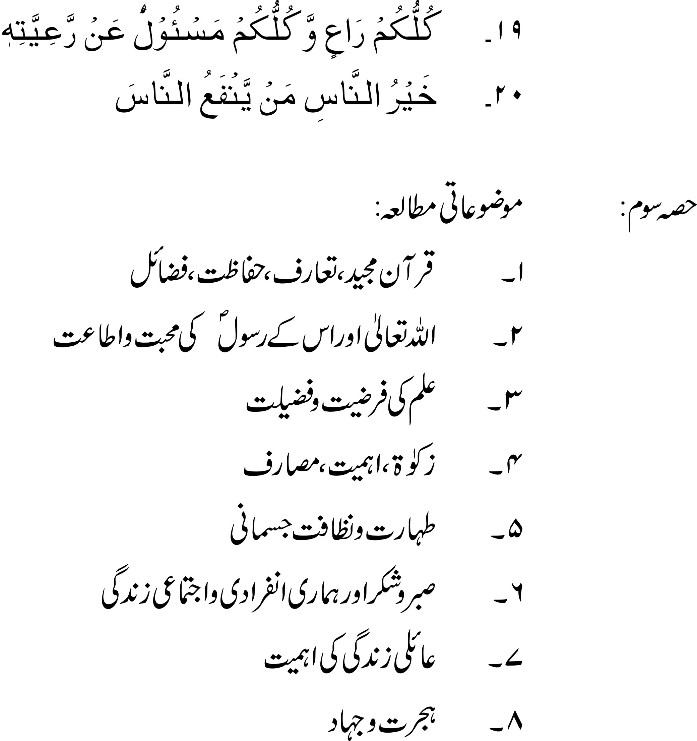

RECOMMENDED REFERENCE BOOKS FOR CLASS IX

The question paper will be syllabus oriented. However, the following books are recommended for reference and supplementary reading:

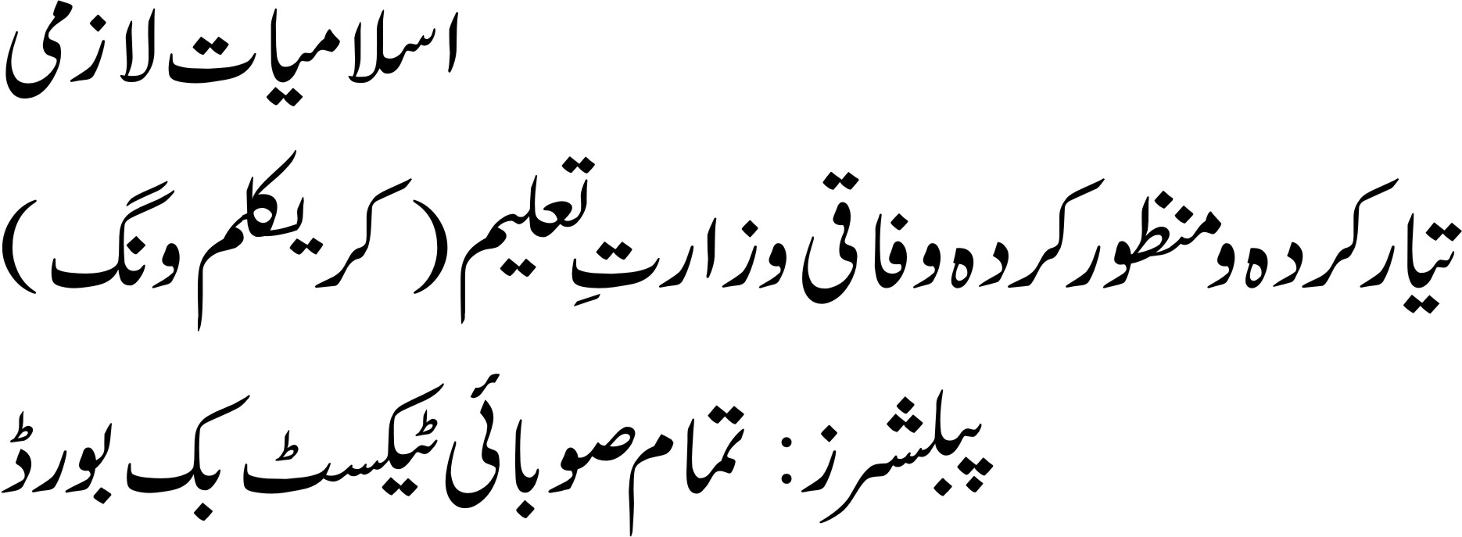
Islamiyat Textbook for Classes IX & X as prescribed by the Provincial Textbook Board in each province.

IKHLAQIAT/ETHICS
In lieu of Islamiyat Compulsory

1. Nature and Importance of Morality
Morality: Purposeful and value oriented discipline.
Ultimate Aim: Obtaining knowledge of character building.
Inculcation of' the concept that individual character and society can be reshaped for a better future
2. Moral Values
Man: a value-oriented being.
Self respect, respect for life, honour and property of others, courtesy. Honesty, dignity of Labour, earning by fair means
Disciplined behavior and international brotherhood

3. God: Bearer of All Virtues
God as the only and unique Divine power and bearer of all virtues who rewards and punishes justly for the deeds of human beings
4. Moral Behavior and Life, After Death
Life after death as mainstay in Moral life
Limited span of life and its logical constraints
Implication of life after death keeping in view the religious and Moral Perspective
5. Biographies of the Expounders of World Religions
1. Hazrat Isa (AS)
2. Hazrat Muhammad (PBUH)
3. Muhatma Budh
4. Zoroaster
5. Kirshne
6. Guru Nanak
Highlights
1. Biographical sketches.
2. Message specially in relation with Morality
3. Role in promotion of civilization.
4. Practical contribution to the evaluation of human civilization.
6 Development of Character Pattern & National Outlook
a. Individual Fights and Obligations
Necessity for realization of moral values, Institution i.e., family, neighbourhood and schools in the making of moral fabrication
b. Tolerance
Role of tolerance in civilized society
Importance of tolerance in relation to religion, customs, ideas and ideals
c. Respect for Law
Evolution of law for the maintenance and perpetuation of better human life
Respect for law: basis of social environment

RECOMMENDED REFERENCE BOOKS FOR CLASS IX

The question paper will be syllabus oriented. However, the following books are recommended for reference and supplementary reading:
1. | 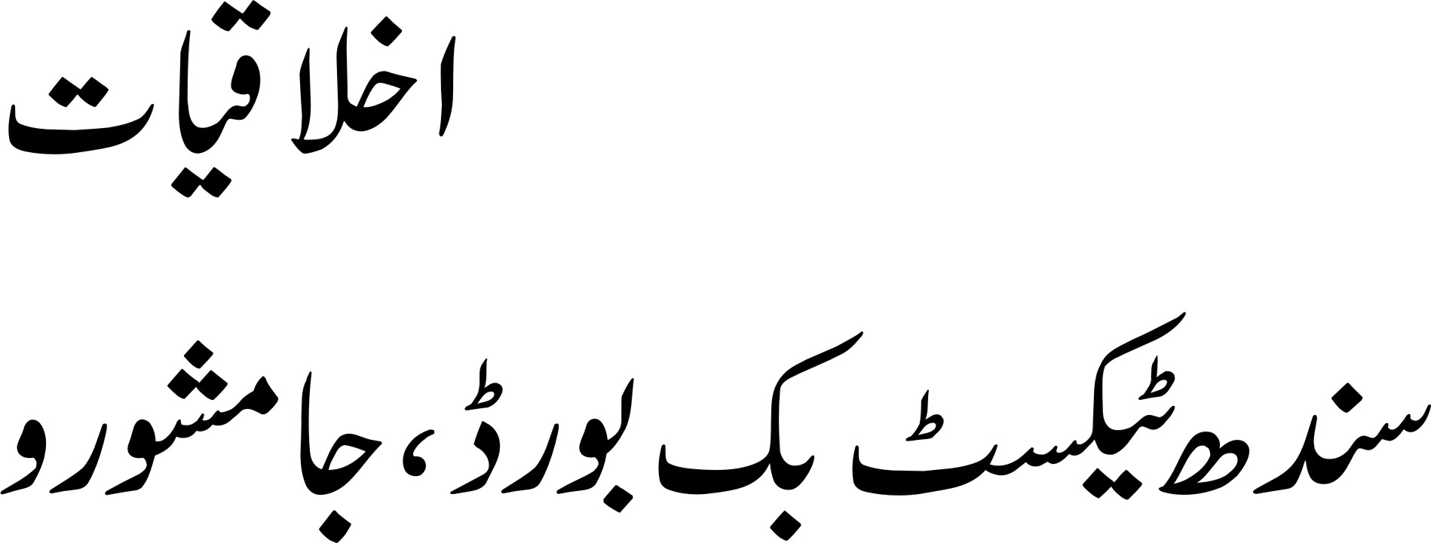
2. | Stories from Saadi, Roomi, Sir Syed Ahmed Khan (Maqalaat, Tehzibul akhlaq) Muhammad Hussain Azad, Deputy Nazir ahmad, Maulana Altaf hussain Halif and Shibli Nomani

